Homework6

The main motivation for this assignment was using support vector binary classification algorithm for every class in order to get one-versus all support vector classification algorithm. In order to achieve that I mapped Y values. What I mean is, Support vector algorithm for class label 1, takes the Y values as positive class for class label 1 and rest of the class labels are negative class. , Support vector algorithm for class label 2, takes the Y values as positive class for class label 2 and rest of the class labels are negative class. , Support vector algorithm for class label 3, takes the Y values as positive class for class label 3 and rest of the class labels are negative class. Support vector algorithm for class label 4, takes the Y values as positive class for class label 4 and rest of the class labels are negative class. Support vector algorithm for class label 5, takes the Y values as positive class for class label 5 and rest of the class labels are negative class.

After I use support vector binary classification algorithm for each class. I pick the maximum similarity in order to decide which class.

As the C increases we are not letting our algorithm not to make mistakes in classification for our training dataset. However, it causes over fitting and, it decreases the efficiency of test data. As the C goes to infinity we don’t allow misclassification.

This is my result for training data

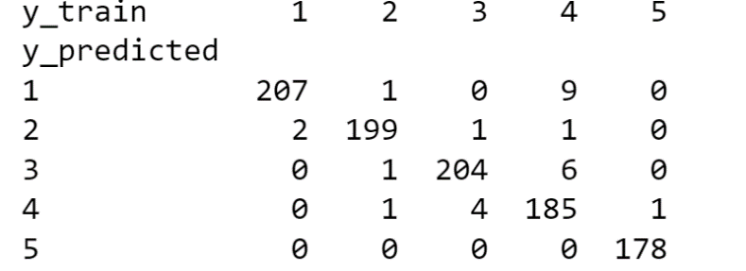

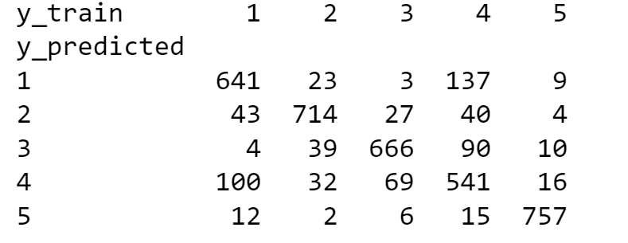This is my result for test data

This is my accuracy graph

